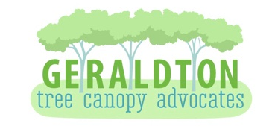
Geraldton Tree Canopy Advocates (GTCA) is a community group of volunteers passionate about improving the liveability of our beautiful city of Geraldton and surrounds.
Our focus lies with the planting of trees on verges and in public spaces to provide a green canopy that will shelter and cool our streets from the hot sun whilst providing habitats for local birds, inspects and wildlife.
GTCA is the first regional advocacy group and is aligned with the WATCA and works in partnership with CGG to support their commitments under various local government green plans, projects and targets.

There are two ways you can plant a verge tree.
- A street tree can be supplied and planted by the City of Greater Geraldton upon the request of the property owner. The CGG annually undertakes street tree planting, and this occurs during the cooler months, generally May and June. The CGG is responsible for the post planting care and maintenance of all street trees, however, property owners/residents will be encouraged to assist with street tree watering during the hotter months. Contact the City of Greater Geraldton to request your name to be added to the planting list for the upcoming planting season.

- Purchase, plant and care for your own verge tree. Approval from the City is not required before any landscaping on the verge is undertaken, as long as the property owner does the work in accordance with the City’s specifications.

Contact ‘Before you Dig’ on 1100 or go to www.1100.com.au to ascertain the location of any underground services on your verge. Select a tree from the recommended list in this pamphlet or on the CGG website according to the soil type in your area. Trees can be purchased from local nurseries (Mooreview and Drylands Permaculture). Follow the planting guide and aftercare guide in this pamphlet.

CGG verge tree planting specifications:
https://www.cgg.wa.gov.au/Profiles/cgg/Assets/ClientData/Documents/Infrastructure/ISV001_-_Verge_Treatment_Specifications.pdf
Generally:
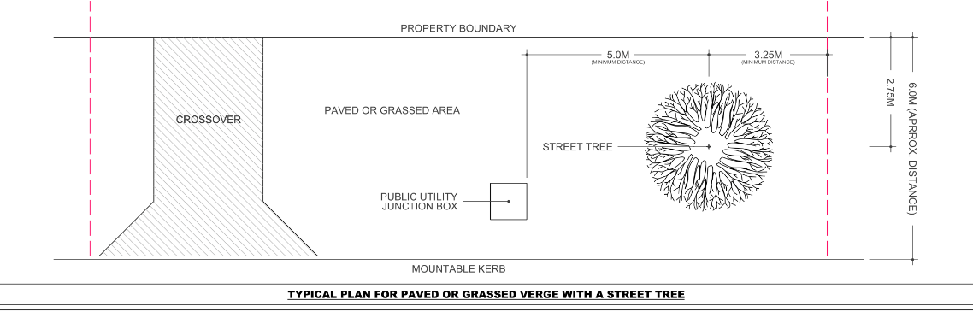
2.75 meters from property boundary
3.25 meters from neighbour or driveway
5 meters from any public utility box

For further information refer to the link below which states:
https://www.cgg.wa.gov.au/Profiles/cgg/Assets/ClientData/Documents/Infrastructure/ISV003_-_You_and_Your_Verge_Book.pdf
A strip of soil approximately 60cm wide and 2.75m from the front property boundary has been set aside for the planning of street trees by the City.
Do you need help?
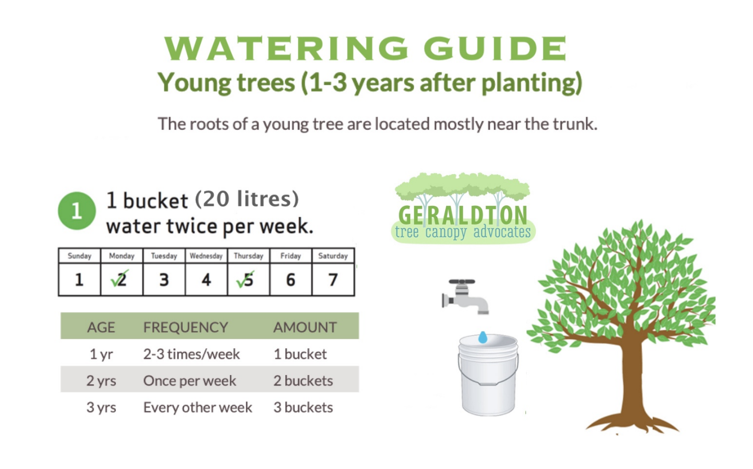
We are here to help you. If you would like to plant a verge tree but need help or are not sure where to start, please contact us at geraldtontca@gmail.com
